CITY OF MISHAWAKA

MILITARY HOMETOWN HEROES PROGRAM

Upon submittal of this application, please review the City of Mishawaka Military Hometown Hero Banner Program guidelines for further details. The initial cost per banner is $200.00 for the production, installation, and removal of the banner. If you are applying to install a previously displayed banner that is still in good condition, the cost of installation and removal of the banner is $40.00. The banner will be displayed from Memorial Day to Veterans Day of each year. Please send a check or money order payable to the City of Mishawaka along with the completed application to:
City of Mishawaka ‐ Military Hero Banner Program c/o Mayor Dave Wood’s Office
100 Lincolnway West Mishawaka, IN 46544

Honoree Information
Name of Service Person: *
First MI (if used on banner) Last
* Spelling of Service person’s name on the banner will be taken directly from the application.
Is Service Person a resident of the City of Mishawaka?  Yes  No Branch of U.S. Military Service:

- U.S. Army
- U.S. Marine Corps
- U.S. Navy
- U.S. Air Force
- U.S. Coast Guard

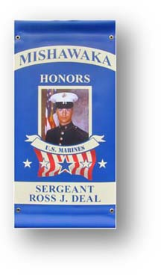
Designated Rank to appear on banner:
Indicate the type of banner you would like to order:
- Active Duty  Veteran  Memorial

What you will need to submit:
- Application
- 5 x 7 high quality photo of the Service Person in uniform.
(Photo will not be returned. Please do not send original photo.)
- Military Verification Form (e.g. Military ID, DD214, etc.)
- $200.00 payable to City of Mishawaka. Please reference “Military Hero Banner Program” on the check.

Applicant Contact Information
Please complete the following information to allow us to contact you should we have any questions. Name: Street Address: City: State: Zip: Home Phone: Cell Phone:
Email:

Relationship to Service Person:

The Service Person being honored (if living) will need to grant permission to for their name and likeness to be placed on a banner in the City of Mishawaka. A separate form has been provided for this.

You can verify military records online by visiting
http://www.archives.gov/veterans/military‐service‐records/

For Additional information please contact the City of Mishawaka Mayor’s Office at: Debby Gregg
Administrative Assistant
(574) 258‐1601
dgregg@mishawaka.in.gov

