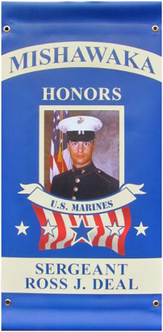
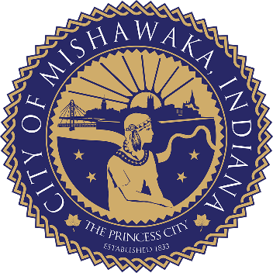
CITY OF MISHAWAKA
MILITARY HOMETOWN HEROES PROGRAM

GUIDELINES AND SPONSORSHIPS

The Military Hometown Heroes Banner Program was created to honor and recognize military personnel (active, honorably discharged or deceased) that reside or have resided in the City of Mishawaka; those who can and do call Mishawaka their hometown. The program is funded through the payments which enable the purchase and placement of the banners on City lampposts.
Banners measure approximately 18” x 37” and will have the Service Person’s name, image and military branch. Those military men and women who have been honorably discharged will be designated with a white star, those who have died in the line of duty a gold star and active duty members will be designated with a blue star.

GUIDELINES

- Honoree must be honorably discharged or deceased or on active duty with any branch of the United States Military.
- Honoree must be a Mishawaka resident.
- Each banner will list the honoree’s name and branch of service and will be proudly displayed on a lamppost in the City of Mishawaka.
- The City of Mishawaka will have the sole responsibility of hanging and removal of the banner. Once produced and installed, banners shall remain the property of the City of Mishawaka until removed and presented to the family or requestor.
- The banner will be displayed from Memorial Day to Veterans Day and upon removal, the banner will be returned to the person who made the original application request. If the banner starts to show any signs of deterioration before the planned removal date, the banner will be removed and returned to the requestor.

